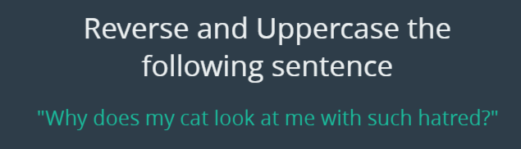

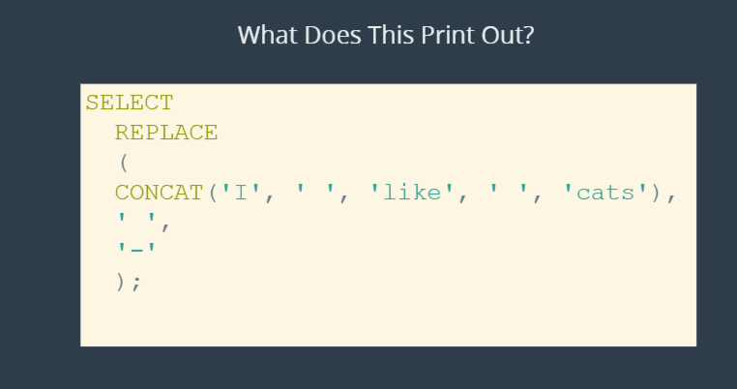 Ans. I-like-cats

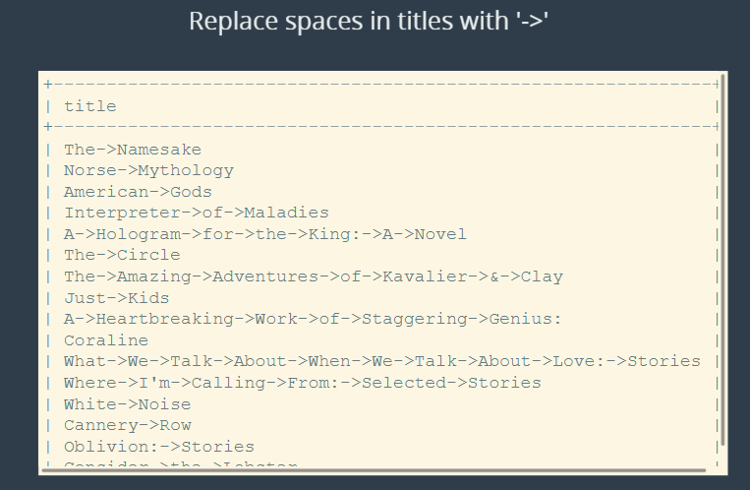

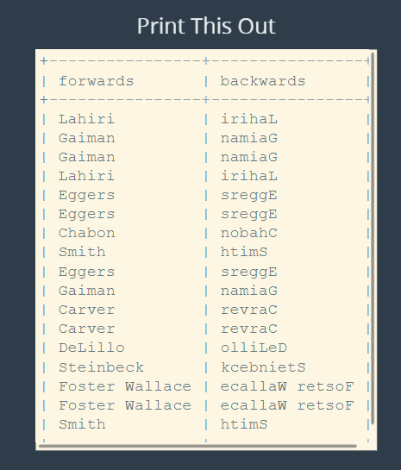

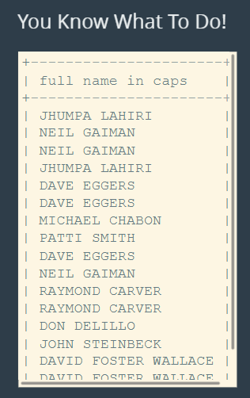

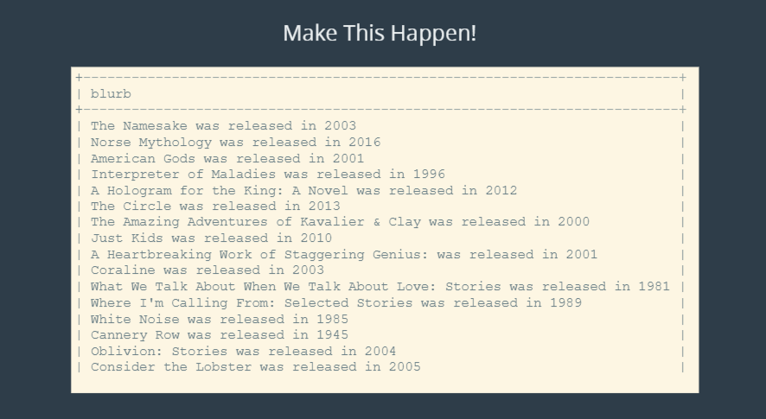

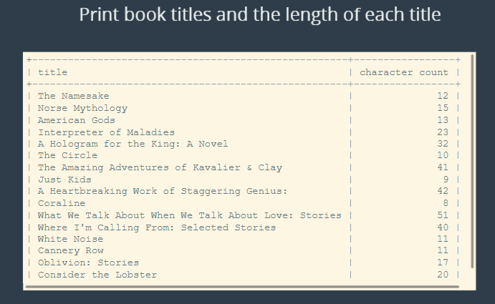

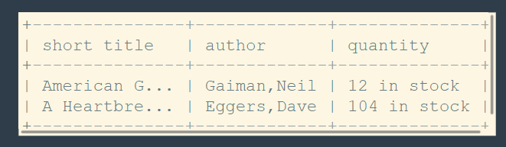

The solutions:

select reverse (upper("Why does my cat look at me with such hatred?"));

select replace(title, ' ', '->') from books;

select author_lname as forwards, reverse(author_lname) as backwards from books;

select upper(concat(author_fname, ' ', author_lname)) as 'full name in caps' from books;

select concat(title, ' was released in ', released_year) as blurb from books;

select title, char_length(title) as 'character count' from books;

select

concat(substr(title, 1, 10), '...') as short_title,

concat(author_lname, ',', author_fname) as author,

concat(stock_quantity, ' in stock') as quantity

from

books;